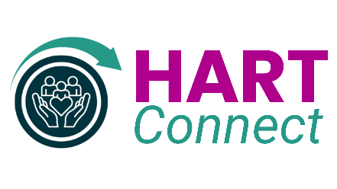
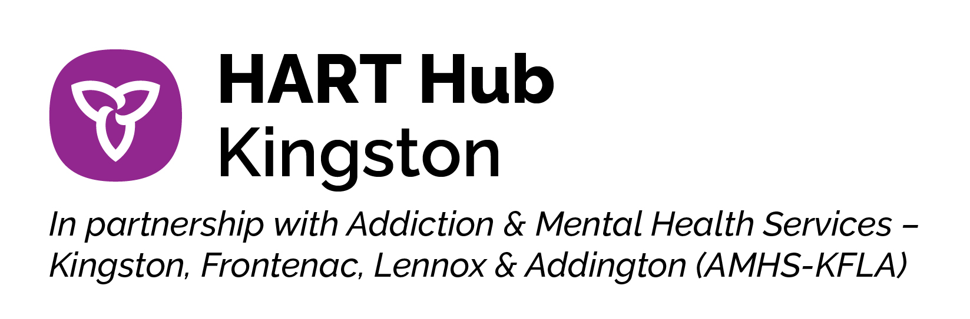
HART Hub Kingston Community Engagement Committee (hereafter CEC): Expression of Interest in Committee Membership

Purpose of the CEC:
The purpose of the CEC is to monitor services provided and address community safety and security concerns related to HART Hub services, and to work collaboratively within committee membership to understand and help inform the services provided at HART Connect.

Membership
Members are required to attend at least 70% of meetings, which will be held monthly.

To be considered for membership as a Neighbour or Local Business membership, you must reside or have a business in the following area: Montreal Street from the corner of Montreal and Rideau Streets to the Belle Park entrance) and Rideau Street (from the intersection of Montreal and Rideau Streets to Rideau Street at Cataraqui Street.)
☐ I am interested in being considered for membership of the CEC
☐ I live or run a business within the geographical area outlined above
I am interested in being (please choose only one)
☐ a Neighbour representative (3-5 members will be selected)
OR ☐ a Local Business Rep (1-2 members will be selected)
OR ☐ a Client or Client Representative (1-3 members will be selected)

I would like to be a member of the CEC because:
(The box above will expand if completed electronically. If completing a paper copy, use the back of this page for extra space if needed.)
Contact Information:
Name:
Address:
Phone #: |  | ☐ Cell ☐ Landline
Email |  | Preference ☐ Phone ☐ Email

For more information on the CEC, please contact: info@amhs-kfla.ca

